**GPIO Usage Guide**

1. GPIO definition: front view from left to right

|  |  |  |
| --- | --- | --- |
| **Serial no** | **symbol** | **describe** |
| 1 | Output1R | Universal optocoupler isolation output terminal 1+ |
| 2 | Output1L | Universal optocoupler isolation output terminal 1- |
| 3 | Output2R | Universal optocoupler isolation output terminal 2+ |
| 4 | Output2L | Universal optocoupler isolation output terminal 2- |
| 5 | GND | Signal Ground |
| 6 | Input1＋ | Universal optocoupler isolation input terminal 1+ |
| 7 | Input1- | Universal optocoupler isolation input terminal 1- |
| 8 | Input2＋ | Universal optocoupler isolation input terminal 2+ |
| 9 | Input2- | Universal optocoupler isolation input terminal 2- |
| 10 | GND | Signal Ground |

1. API interface reference Demo is as follows

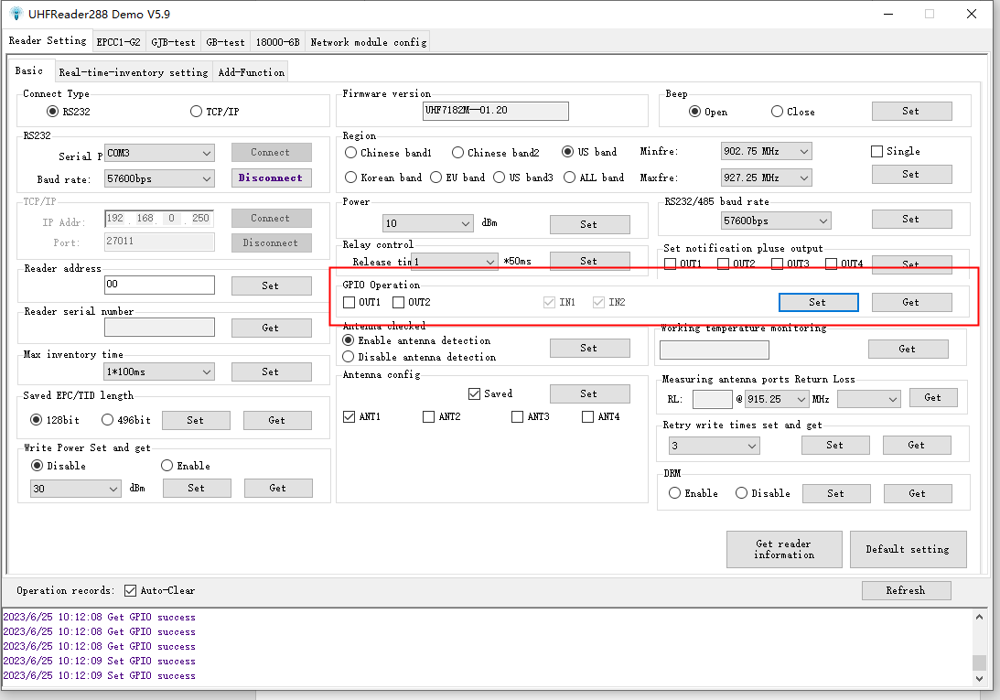

1. GPO Description: Withstand voltage 400V

When OUT1 is set to 1, Output1R and Output1L are turned on, and a 100 R resistor is connected in series. If a relay needs to be connected, the drive power supply DC needs to be connected to Output1R, and Output1L needs to be connected to the relay drive pin.

1. GPI Description: Withstand voltage 10V；

When the voltage of Input1＋ is greater than Input1- by 1V, IN1 is at a low level.

When the voltage of Input1＋ is less than 1V of Input1-, IN1 is high level.

Only IN1 can be used in trigger mode.